Q. Mounting Amazon S3 to an Amazon EC2 instance using a private connection to S3 File Gateway:

🡺

Step 1:-

To Mount s3 bucket on ec2 instance you have to need awa storage gateway service.

Because you have to mount bucket on instance by file gateway. There are many steps but I choose this one. See following steps to how do that.

Step 2:-

Open aws account and go to service storage gateway.

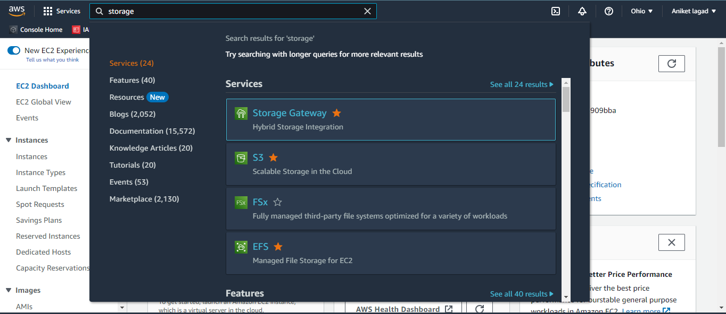

Step 3:-

Now you have to create gateway by hit on create gateway option.

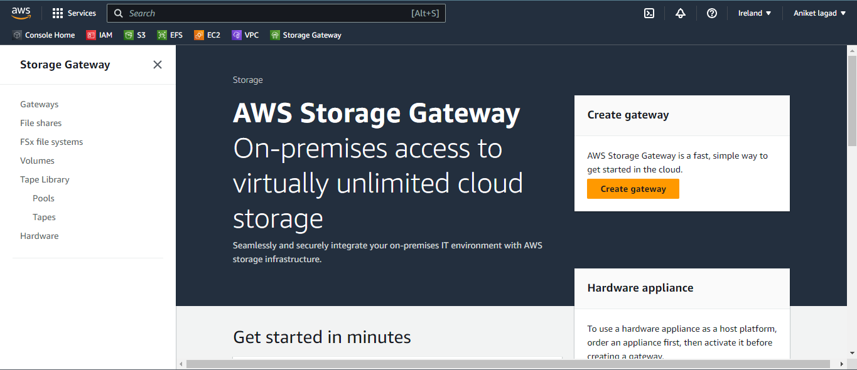

Step 4:-

Now you have see the steps of gateway creating read and scroll down.

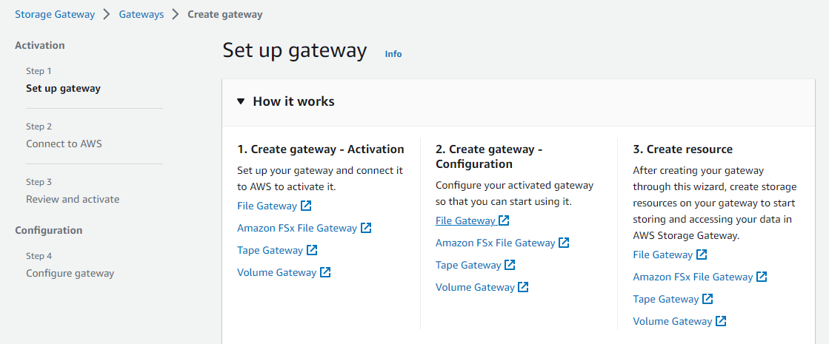

Step 5:-

Gave storage gateway name and after that choose the local time.

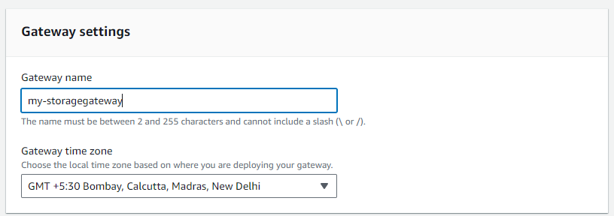

Step 6:-

Now you have select gateway type it means in which gateway type you have to mount.

So we have mount s3 bucket so I will choose amazon s3 file gateway.

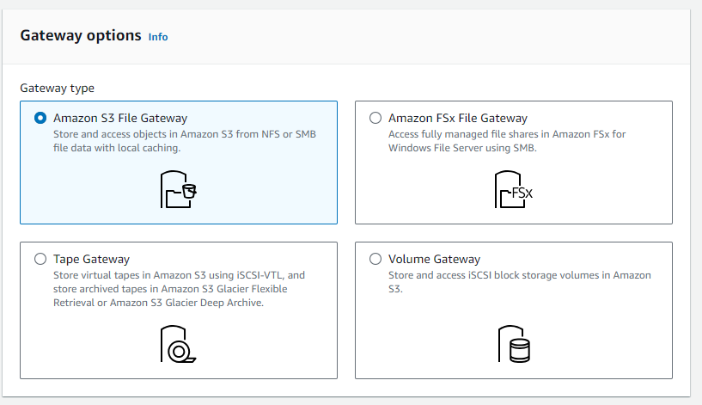

Step 7:-

Next you have to select platform to mount bucket. So we have to mount bucket in ec2 instance that’s why I will choose amazon ec2 option.

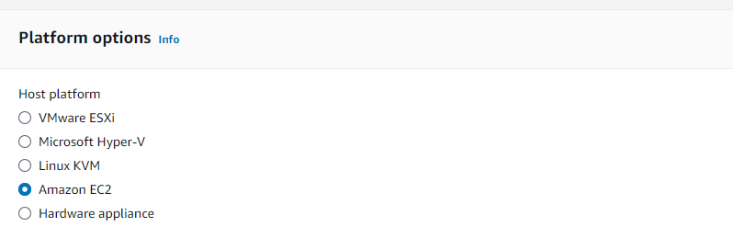

Step 8:-

Now have to launch instance because we create the Amazon S3 File Gateway using Amazon EC2 as the host. So use default setting option and then select your vpc after that choose subnet to launch instance in that availability zone. And next choose appropriate key pair to that instance amd then launch instance.

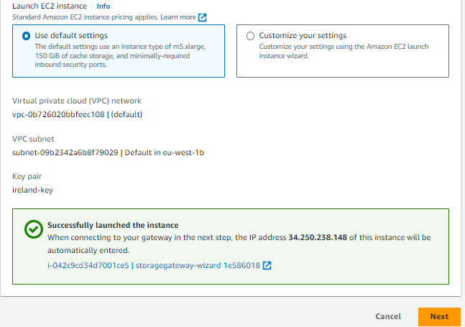

Step 9:-

Now click on next and you have see the connecting to aws step by default select option ip address leave as it is and then your gateway instance ip also file in ip address column.

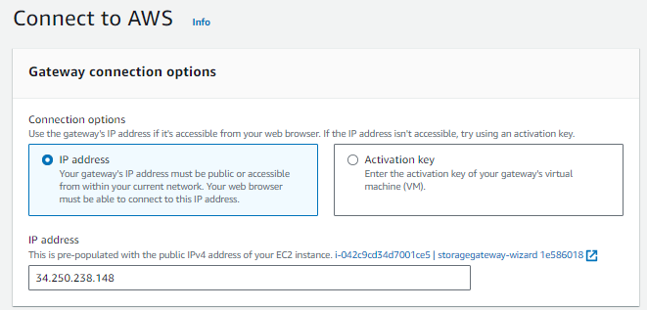

Step 10:-

Now you have to add vpc endpoint that vpc which is your under control all network setting.

There are to options select vpc hosted and then click on vpc endpoint ID. If you have already vpc endpoint then select it or not then click on create vpc endpoint. I have choose create vpc end point.

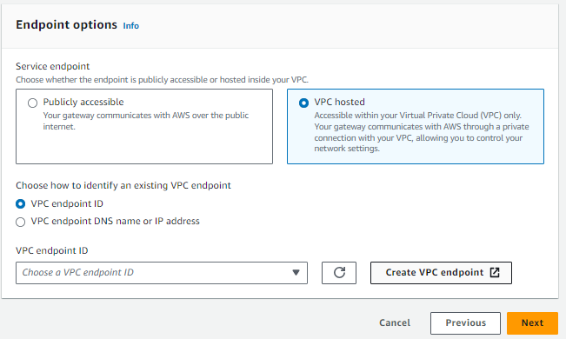

Step 11:-

Now you have see the endpoint create setting gave endpoint name and after that select service category as aws service.

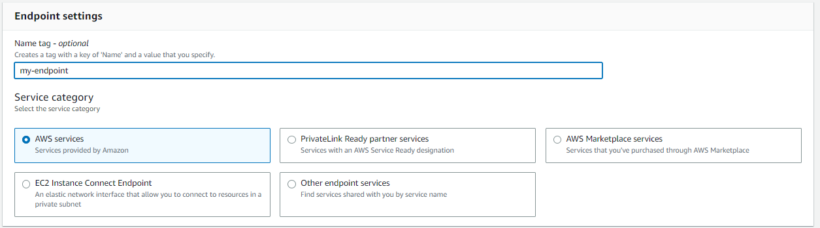

Step 12:-

Now select service search in that box storage then you have see three storage services select •Service Name **=**com.amazonaws.eu-west-1.storagegateway .

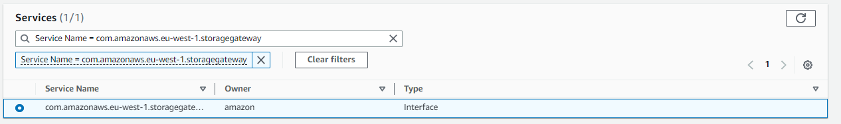

Step 13:-

Now select vpc your vpc name.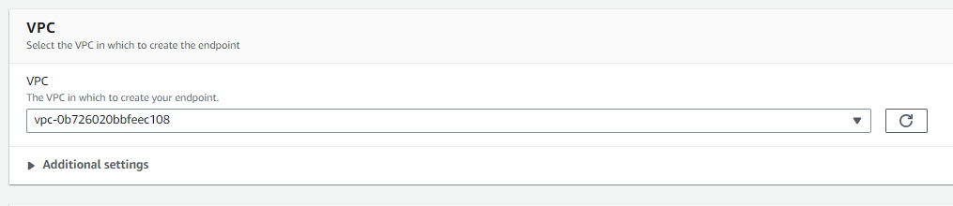

Step 14:-

After that select subnets and then ip address type ipv4.

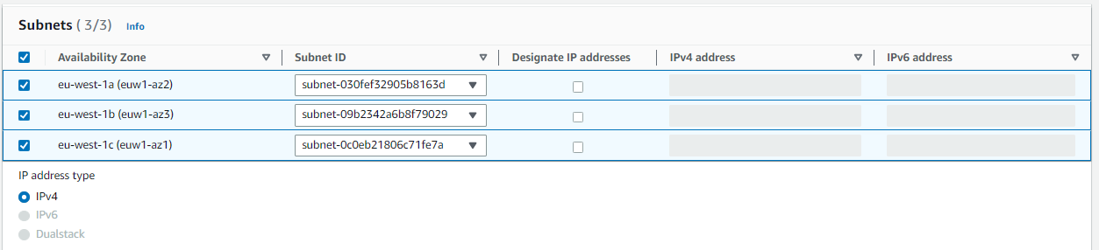

Step 16:-

Now select the security group in which added the port number 2049,1026,1027,1028 and 1031. And then create end point.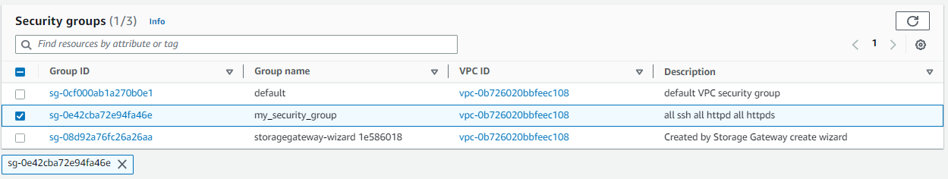

Step 17:-

Now go to gateway page and select your newly created endpoint. And click on next.

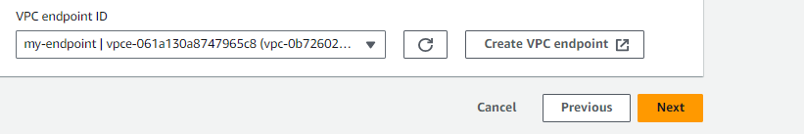

Step 18:-

Now see review page and then click on active gateway option.

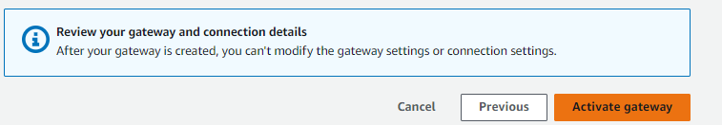

Step 19:-

Now configure the gateway wait fore configure cache storage and then youha to monitoring or notification apply then and click on configure.

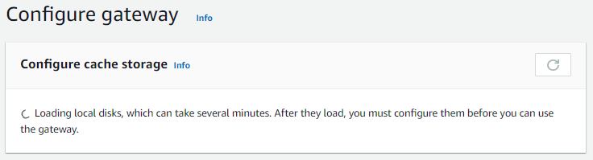

Step 20:-

And your gateway is ready to file share.

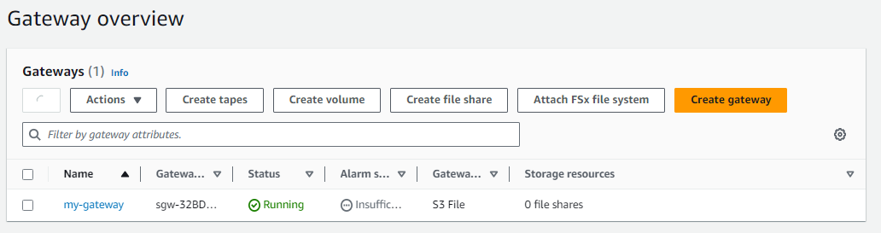

Step 21:-

Now launch a instance to mount s3 bucket by file sharing.

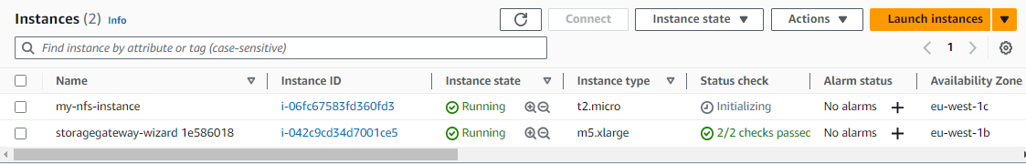

Step 22:-

now you have to create file share from your newly created storage gateway. Open storage gateway service and then click on option file share and thene clickc on create file share.

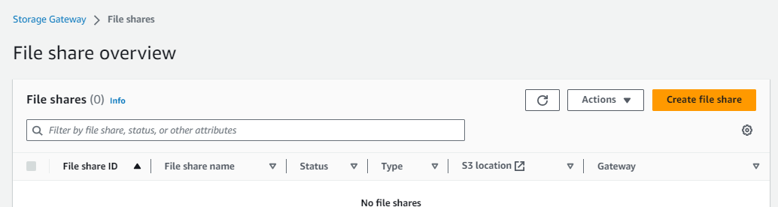

Step 23:-

Now select gateway then file share protocol NFS and then select my---bucket1. And after that click on create file share. 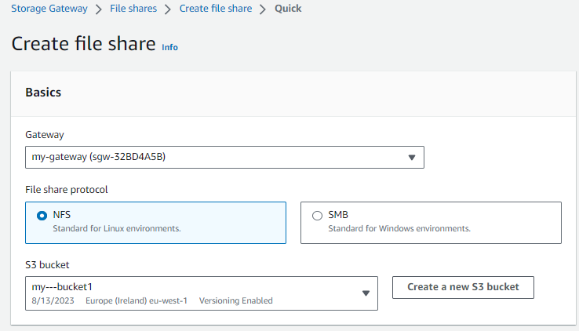

Step 24:-

Now your file share is ready to mount your bucket. Get access of instance which you launch too mount. And then you have to make temporary mount then run command “mount -t nfs -o nolock,hard 172.31.47.122:/my---bucket1 [MountPath] “ or if you have mount permanent then make changes in fstab. I will show only temporary mount.

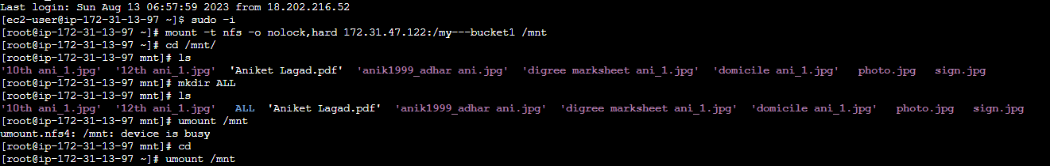

*** THE END***